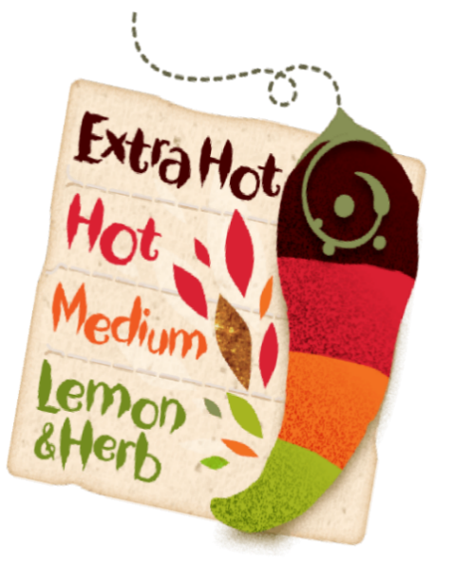
Travel Brochure | Map
Imagine that you are a travel guide creating an information booklet about Yorkshire and Campania.  Create a guide that introduces someone to both locations. | Create a map to show and label the different physical and human features of Yorkshire OR Campania.
Quiz | Poem
Create a quiz about Yorkshire OR Campania– include interesting facts. | Write a shape poem or an acrostic poem linked to our topic.
Crossword | Recipe
Create a crossword using key topic words with their meanings as clues. | Make a traditional recipe from Yorkshire and Humber OR from Campania, Italy.

Parents/Carers –
Homework is an important part of your child’s academic learning. Please support your child with their homework by helping them, sitting with them and showing an interest in what they have been learning. All work can be saved in Google Drive. *Films or photos can be tweeted to @stjosephskly or emailed. If you have any questions, please ask your class teacher.
Have a go at some of these tasks and you will be rewarded with house points.
Try to increase the ‘spiciness’ of the dish each time. The ‘hotter’ the dish, the greater the number of house points.
Lemon & Herb will be a minimum of 5 house points.
Medium will be a minimum of 8 house points.
Hot will be a minimum of 10 house points.
Extra Hot will be a minimum of 20 house points.

